**AYDIN ADNAN MENDERES UNIVERSITY**

**ENGINEERING FACULTY**

**COMPUTER SCIENCE ENGINEERING DEPARTMENT**



**NER On Medical Text Second Part**

**CSE431 – Natural Language Processing with Machine Learning 2023/2024**

**Burak TÜZEL**

**Talha Alper ASAV**

**Lecturer:**

**Asst. Prof. Dr. Fatih SOYGAZİ**

**Named Entity Recognition on Medical Text Second Part**

**Installing necessary environment and importing the libraries:**

1. Install Jupyter Notebook

**Reading the Medical Text Without NER and Preprocessing:**

Here is the medical text link to download: <https://www.kaggle.com/datasets/tboyle10/medicaltranscriptions>

Firstly we read the medical samples data. Then creating a method to  get unique words(vocabulary) and sentence count in a list of text

**Finding the Disease, Drugs and Drugs-Doses Named Entities:**

Here we checked the number of samples in each category. Since some categories have less than 50 we will remove them (You can check the full output from the given .html file)

**Preprocessing to Increase the Accuracy:**

Here we grouped the subcategories into their specialties.

**Here We Used TF-IDF Vectorizer and Started Building Our Models:**

Here is our vectorizer code. We will split it and feed it to the models.

1. Multinomial Naïve Bayes

1. Random Forest

1. XGBoost

1. A screenshot of a crossword puzzle

   Description automatically generatedLightGBM

1. 1D CNN, LSTM and GRU

**Here We Used Bag-of-Words (CountVectorizer) and Started Building Our Models:**

Here is our vectorizer code. We will split it and feed it to the models.

1. Multinomial Naïve Bayes

1. , Random Forest

1. XGBoost

1. LightGBM

1. 1D CNN, LSTM and GRU

**Here We Used TF-IDF Vectorizer for the First Part Output and Started Building Our Models:**

Here is our vectorizer code. We will split it and feed it to the models.

1. Multinomial Naïve Bayes

1. Random Forest

1. XGBoost

1. LightGBM

1. 1D CNN, LSTM and GRU

**Here We Used CountVectorizer for the First Part Output and Started Building Our Models:**

Here is our vectorizer code. We will split it and feed it to the models.

1. Multinomial Naïve Bayes

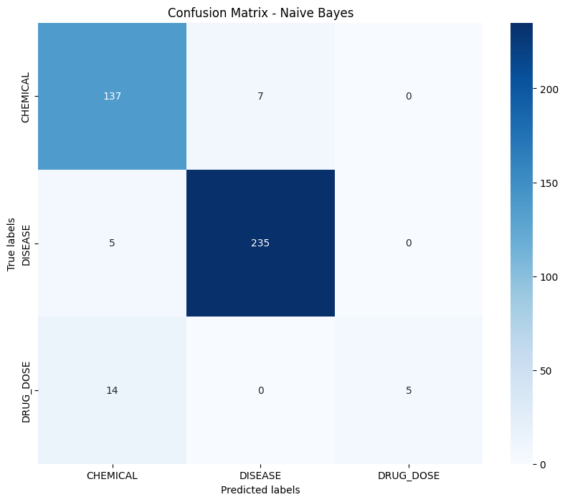

1. Random Forest

1. XGBoost

1. LightGBM

1. 1D CNN, LSTM and GRU

**And Finally Applying SMOTE to Our Best Models:**

For the first input our best model was Multinominal Naïve Bayes with the CountVectorizer.

Here is before oversampling scores.

And here is after oversampling scores.

And for the second input our best model was Random Forest. So we applied SMOTE and compared results for it.

Here are the results before oversampling.

And here are the results after oversampling.

While we saw some improvements on the first input side, for the second input side it got worse.

**REFERENCES**

1. <https://www.kaggle.com/datasets/tboyle10/medicaltranscriptions>
2. <https://www.kaggle.com/code/ritheshsreenivasan/clinical-text-classification>

ssss